Cucumber Tutorial  
1) (….) -> considers any 4 charcters within braces  
2) (abc|def) -> either abc or def  
3) (.\\.*) -> example -> (3.14)  
4) ([0123456789]*) -> to match one of the range of characters  
5)([0-9]*) -> similar to above  
6) Shorthand character classes  
(\\d*) -> digit  
(\\d+) -> atleast one digit  
\D-> negate of \d  
7) \w -> word charcters specifically [a-zA-Z0-9_]  
8) \s -> [\t\r\n]  
9) \b -> word boundary, opposite of \w  
10) cucumbers? -> preceeding character options -> in this case cucumber/cucumbers  
11) @When(“I (?:visit|go to) home  
I visit home  
I go to Home  
12) throws pendingException if a particular step is not defined  
13) DataTable in Cucumber  
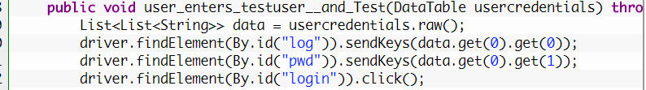  
14)